Sequence Diagram: Group Post Management
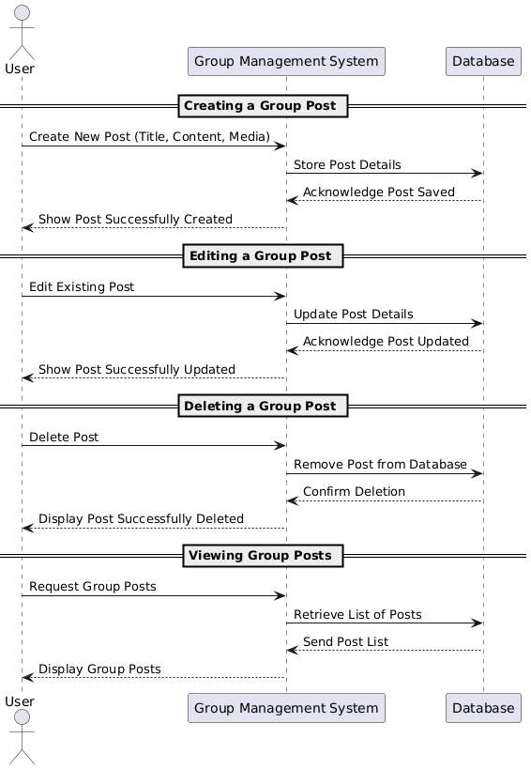
Database
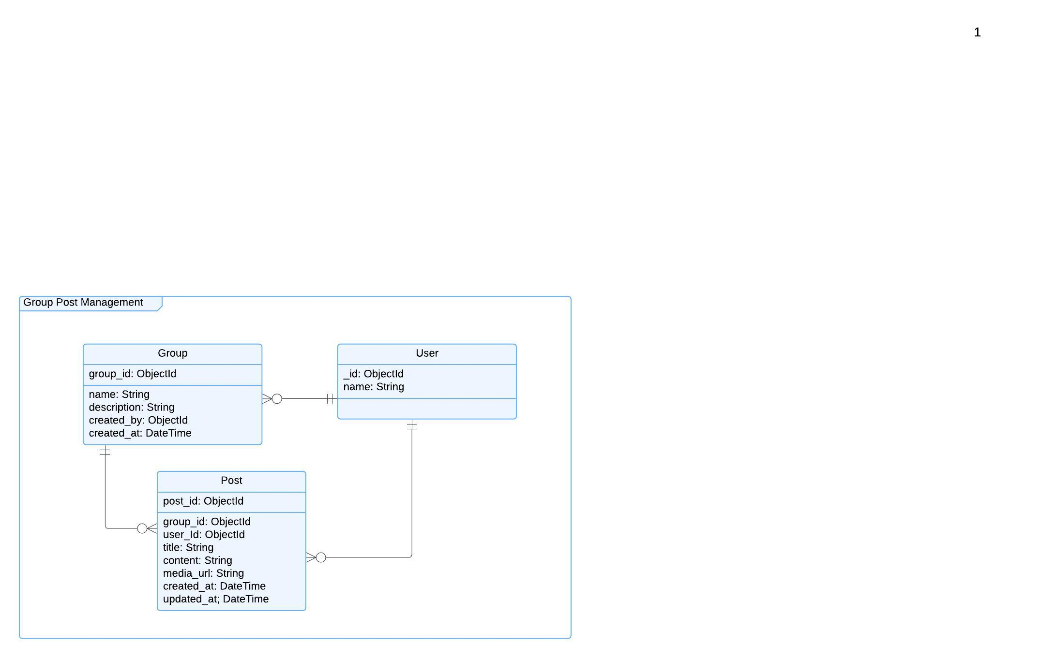

Functional Requirements (FRs)
- FR1: The system shall allow users to create group posts with title, content, and media.
- FR2: Users shall be able to edit their own posts.
- FR3: Users shall be able to delete their posts.
- FR4: The system shall allow users to view all posts in a group.
- FR5: The system shall store timestamps for post creation and updates.
Non-Functional Requirements (NFRs)
- NFR1: The system should allow post creation and updates in under 2 seconds.
- NFR2: The database must support high concurrency for multiple users.
- NFR3: User permissions must be enforced to prevent unauthorized edits or deletions.
- NFR4: All media files must be stored securely with size limits.
- NFR5: The system must provide real-time updates when new posts are added.

